Lab-1: [https://github.com/MicrosoftLearning/AZ-204-DevelopingSolutionsforMicrosoftAzure/blob/master/Instructions/Labs/AZ-204_lab_01.md](https://urldefense.com/v3/__https:/github.com/MicrosoftLearning/AZ-204-DevelopingSolutionsforMicrosoftAzure/blob/master/Instructions/Labs/AZ-204_lab_01.md__;!!Mj5yV84exmbMMB4!qJG60DbYXhJx8wTLDRXU4ALhwkzPyOQWQsjR6iY2YPlJOZ37BYx12ahXcP3WFRZIV0FLoGiMuDQUcHQGM72ZR5NL$)

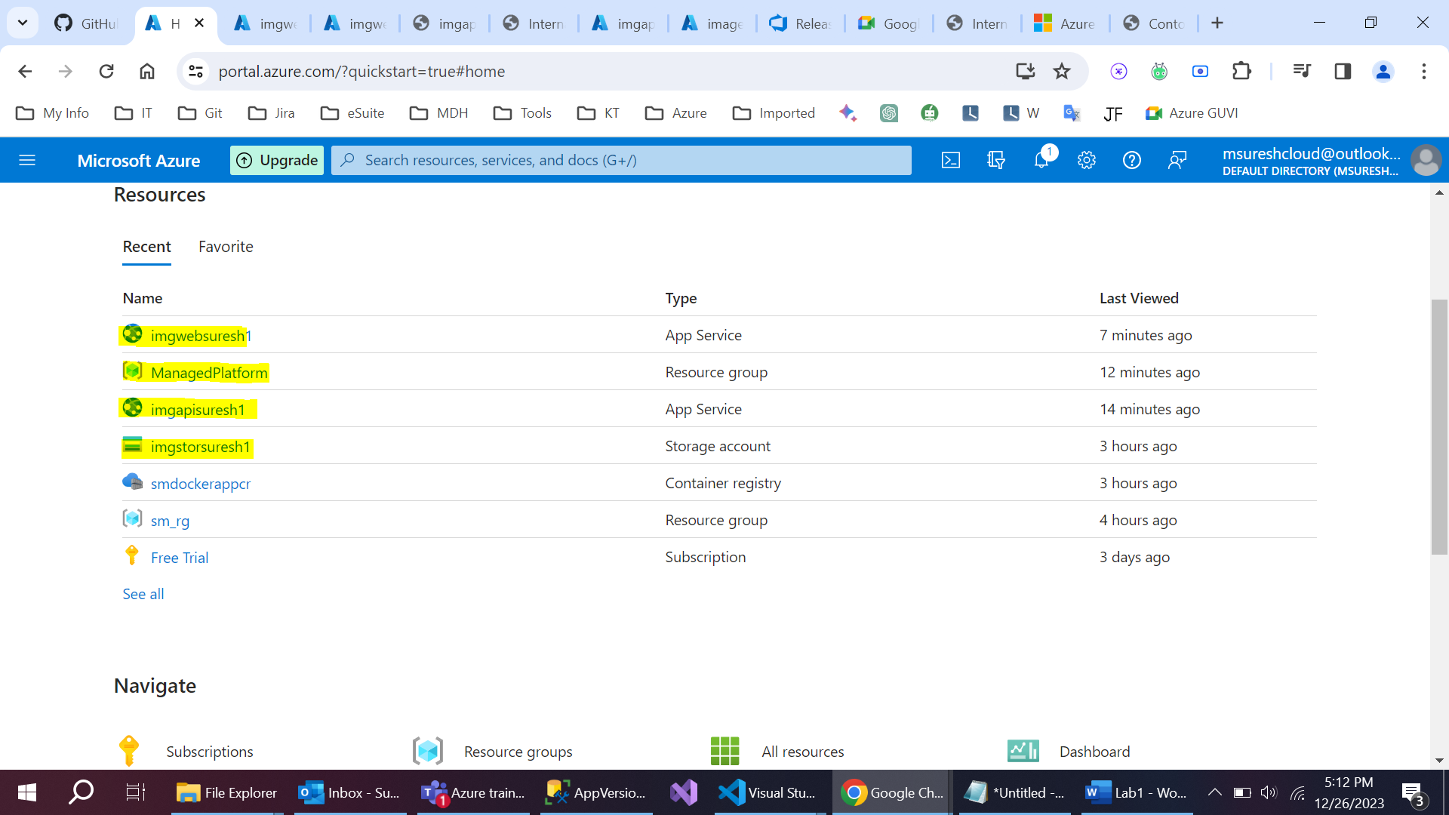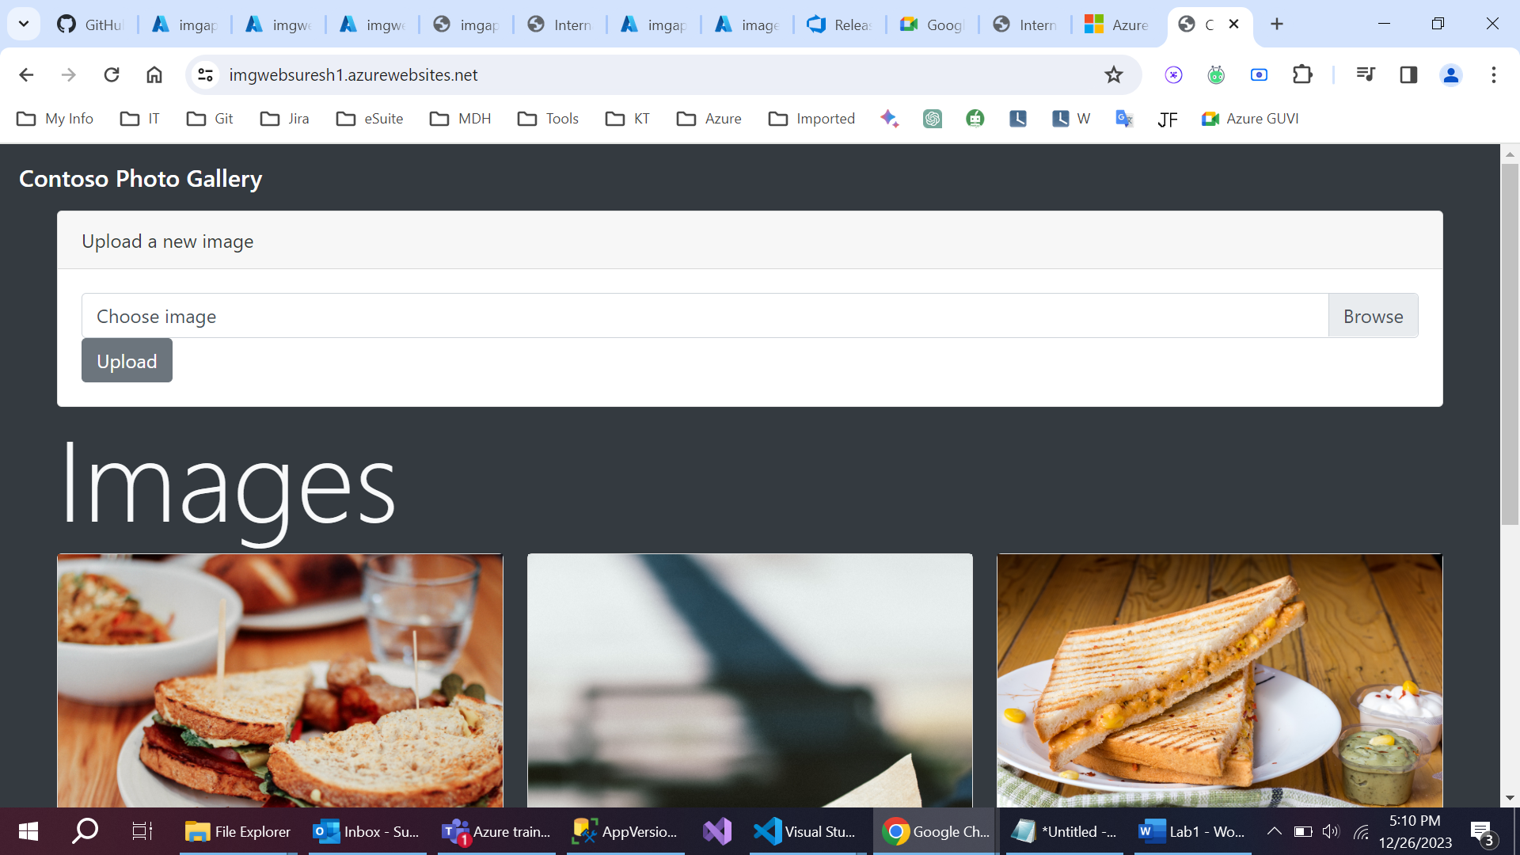

Lab-2: [https://github.com/MicrosoftLearning/AZ-204-DevelopingSolutionsforMicrosoftAzure/blob/master/Instructions/Labs/AZ-204_lab_02.md](https://urldefense.com/v3/__https:/github.com/MicrosoftLearning/AZ-204-DevelopingSolutionsforMicrosoftAzure/blob/master/Instructions/Labs/AZ-204_lab_02.md__;!!Mj5yV84exmbMMB4!qJG60DbYXhJx8wTLDRXU4ALhwkzPyOQWQsjR6iY2YPlJOZ37BYx12ahXcP3WFRZIV0FLoGiMuDQUcHQGMybx2KDk$)

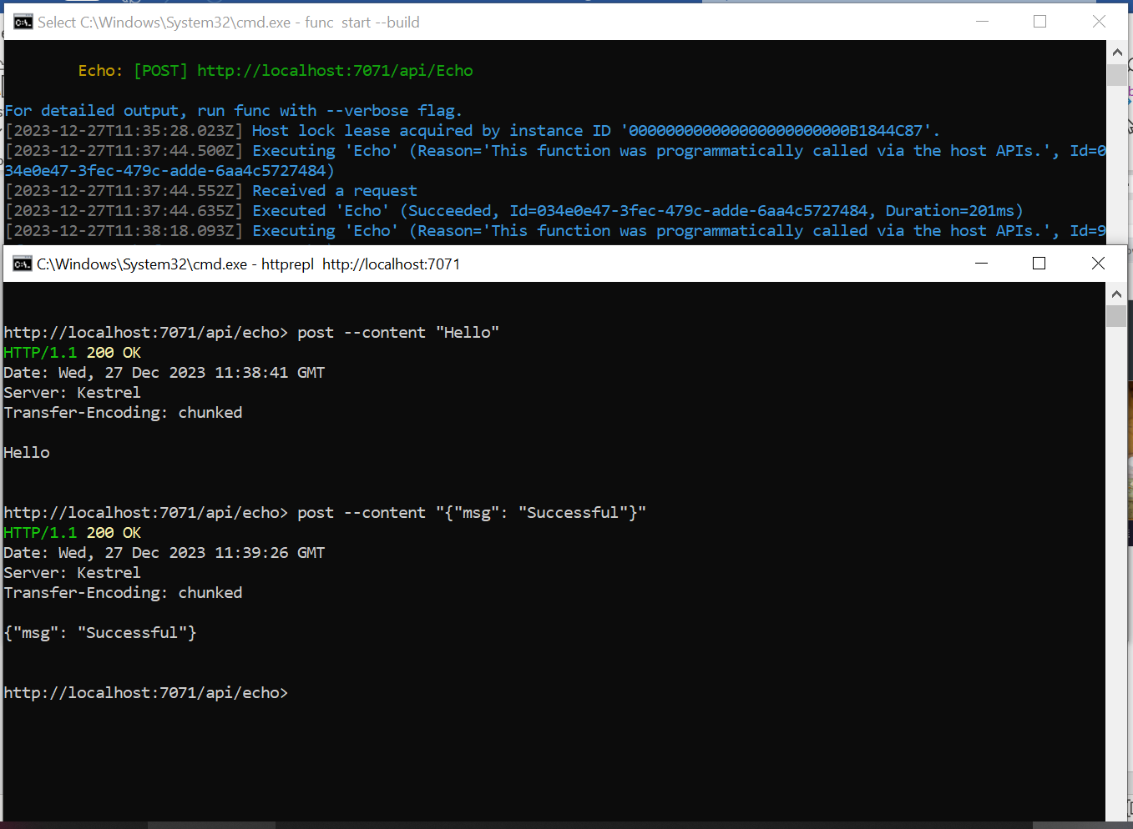

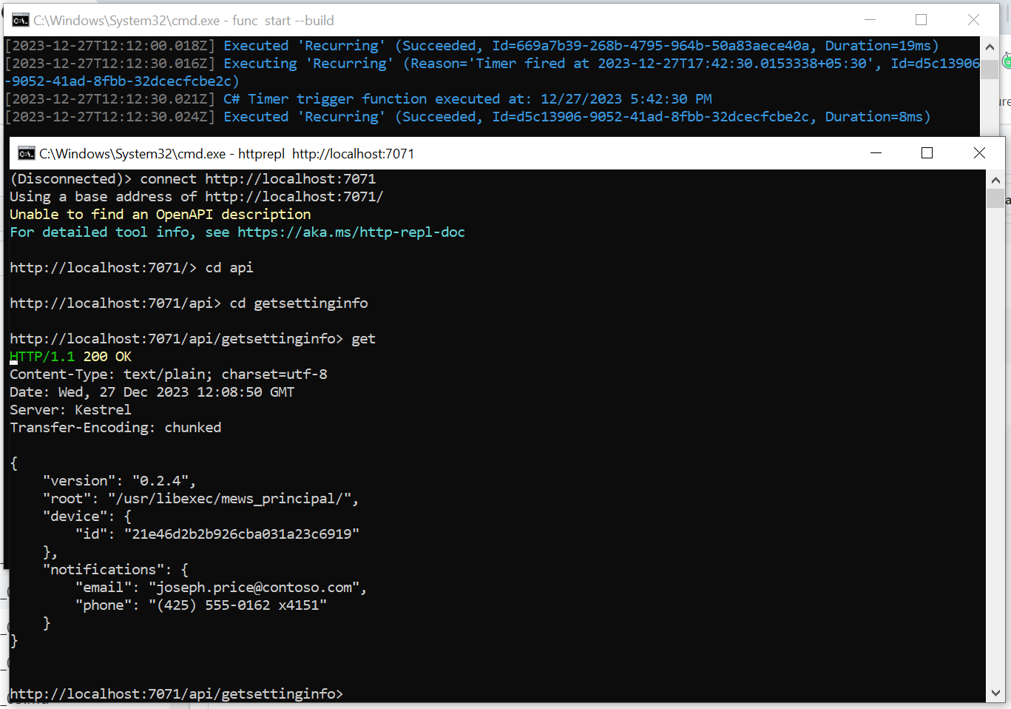

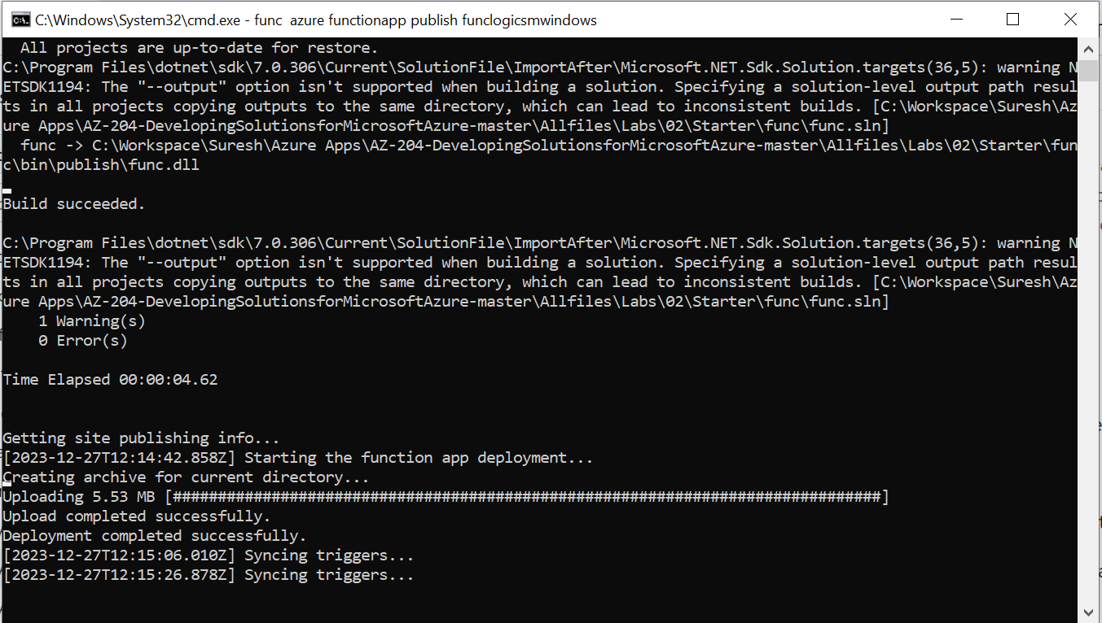

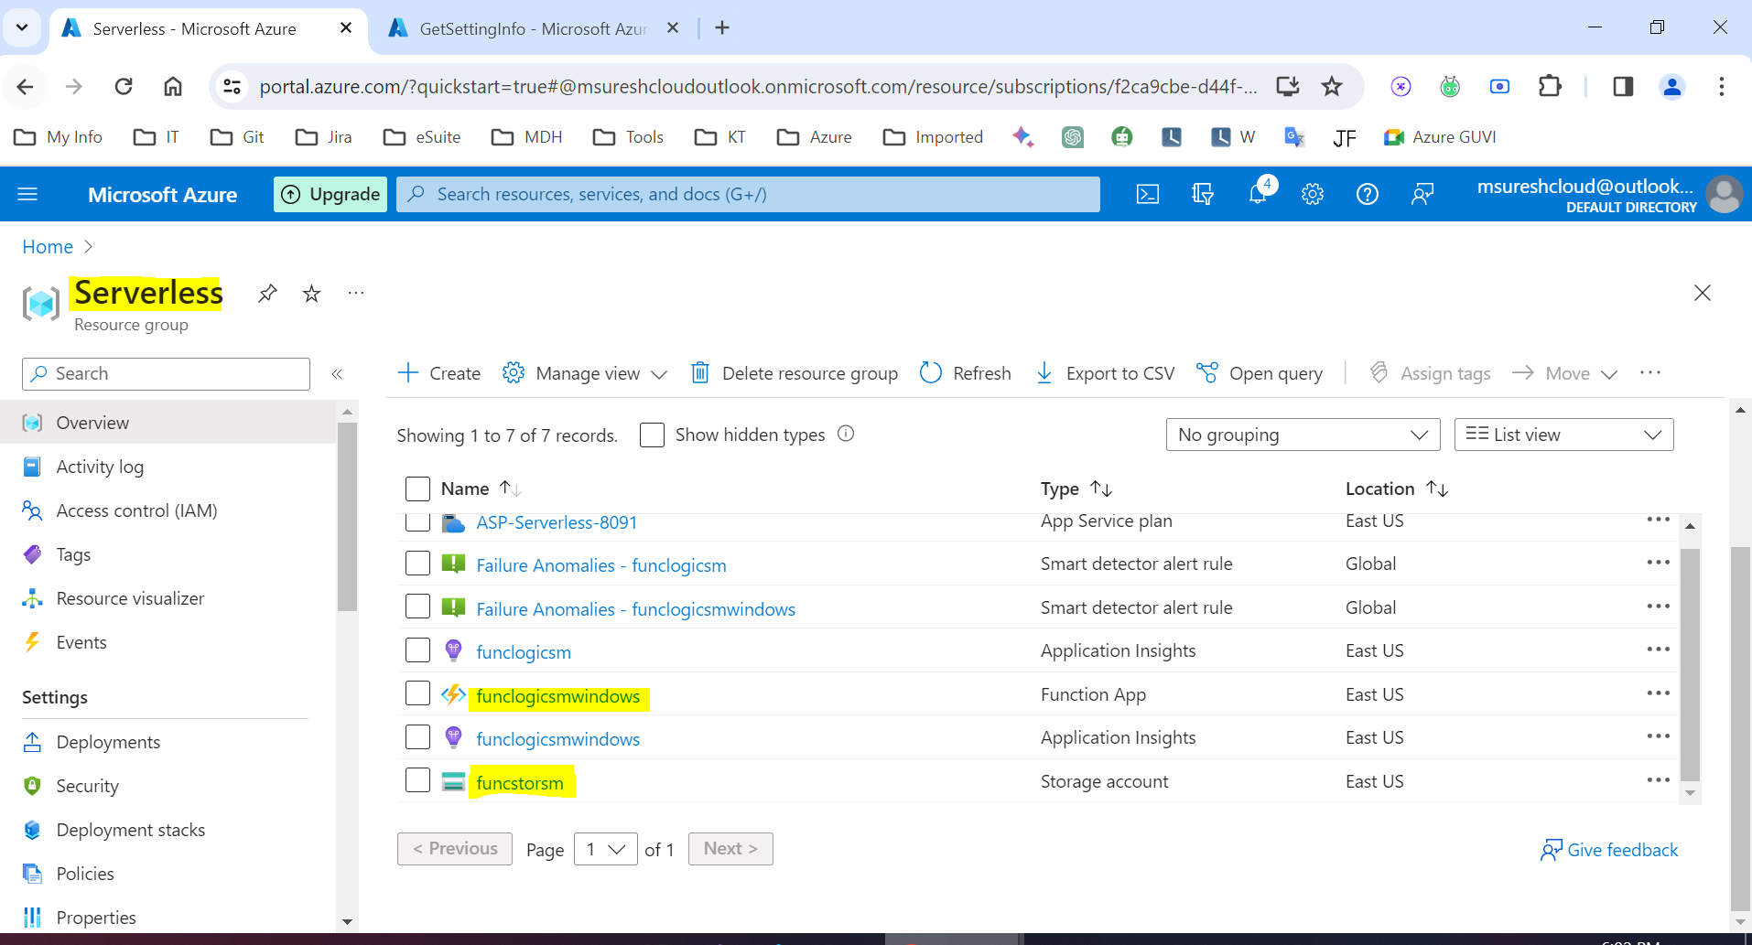

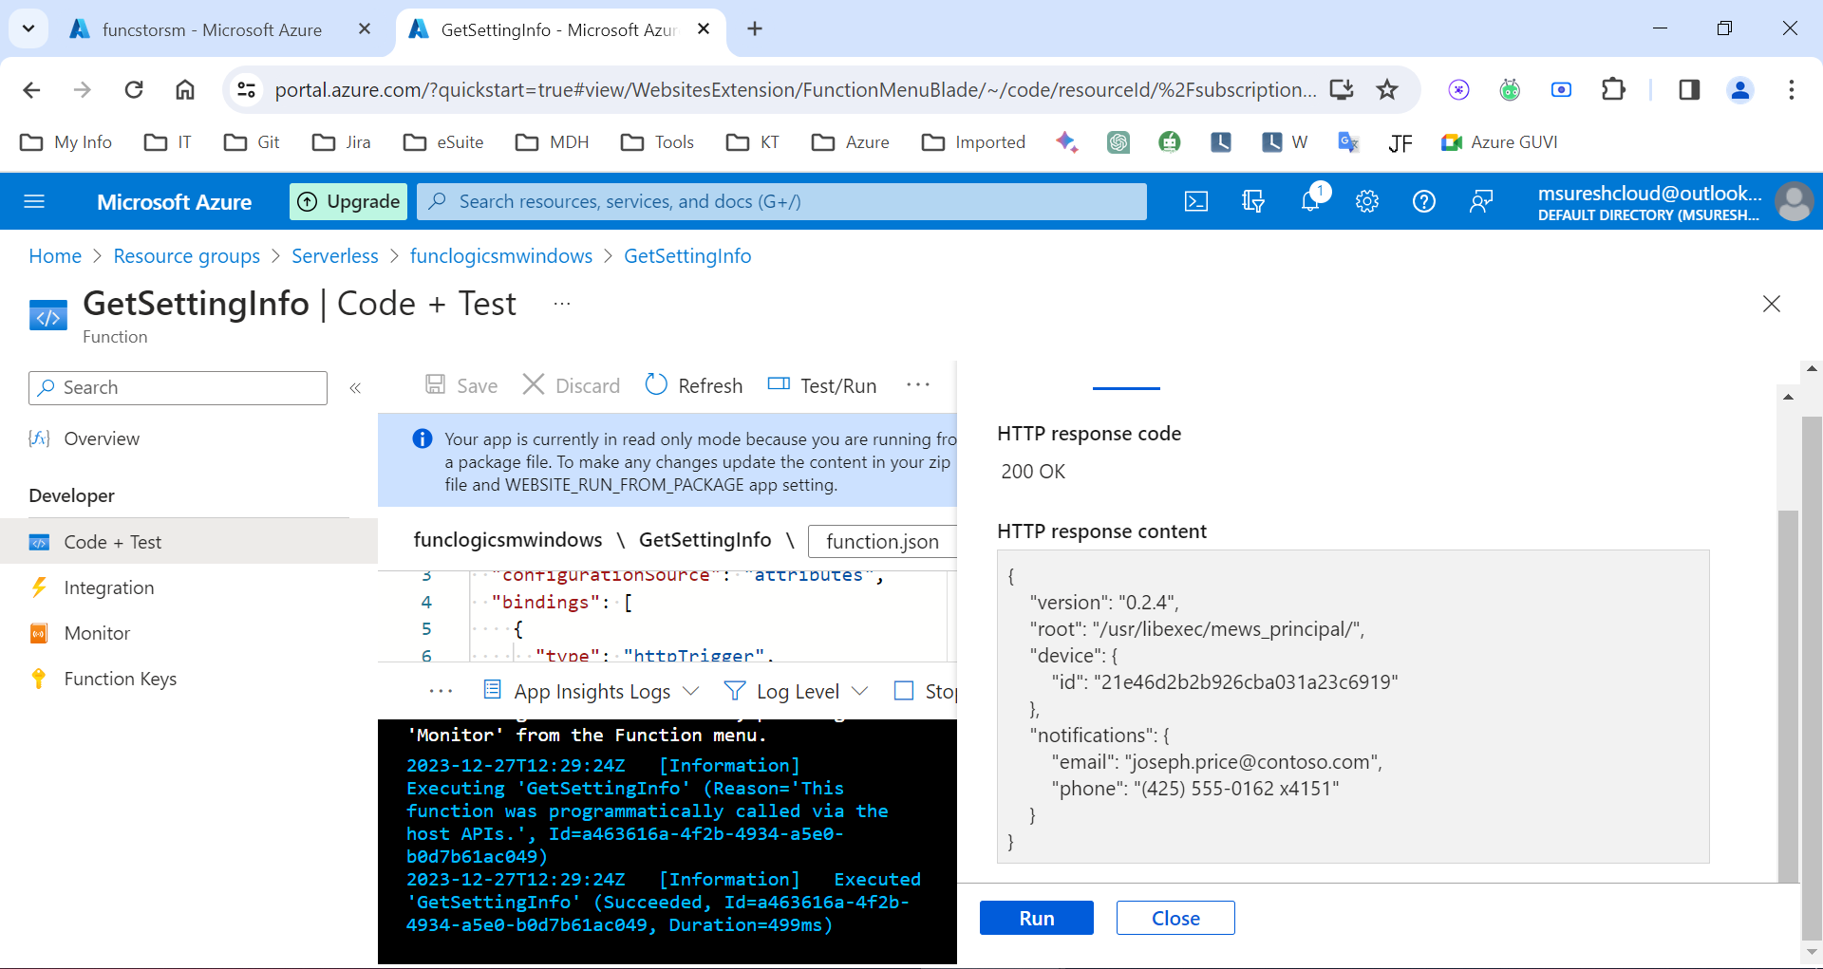

lab-3: [https://learn.microsoft.com/en-us/azure/storage/blobs/blob-upload-function-trigger?tabs=azure-portal](https://urldefense.com/v3/__https:/learn.microsoft.com/en-us/azure/storage/blobs/blob-upload-function-trigger?tabs=azure-portal__;!!Mj5yV84exmbMMB4!qJG60DbYXhJx8wTLDRXU4ALhwkzPyOQWQsjR6iY2YPlJOZ37BYx12ahXcP3WFRZIV0FLoGiMuDQUcHQGM67Qmj74$)

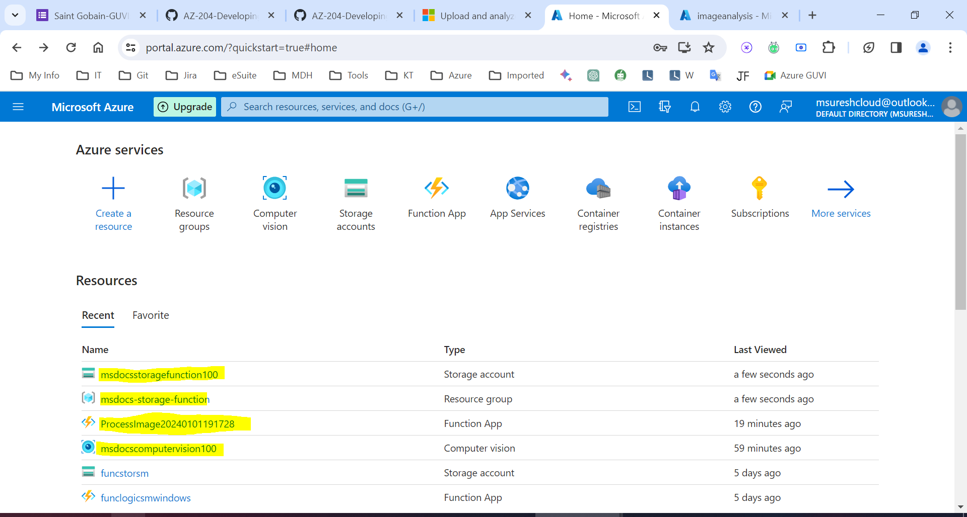

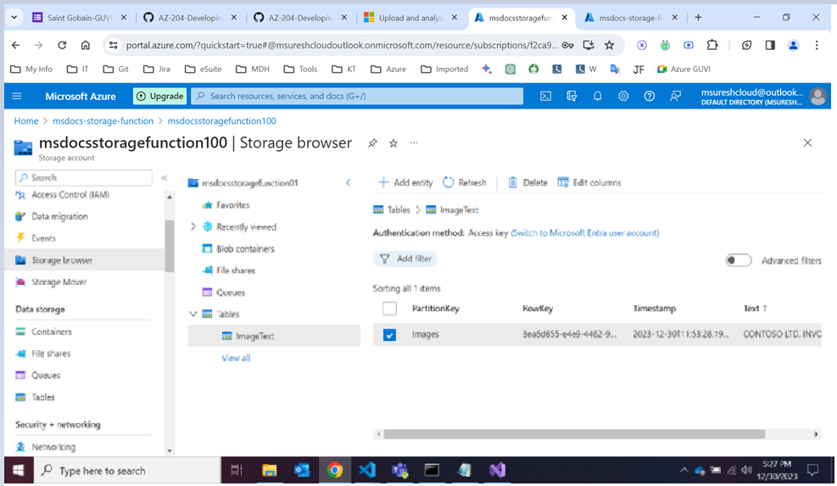

Lab - 4: **Azure Redis Cache**

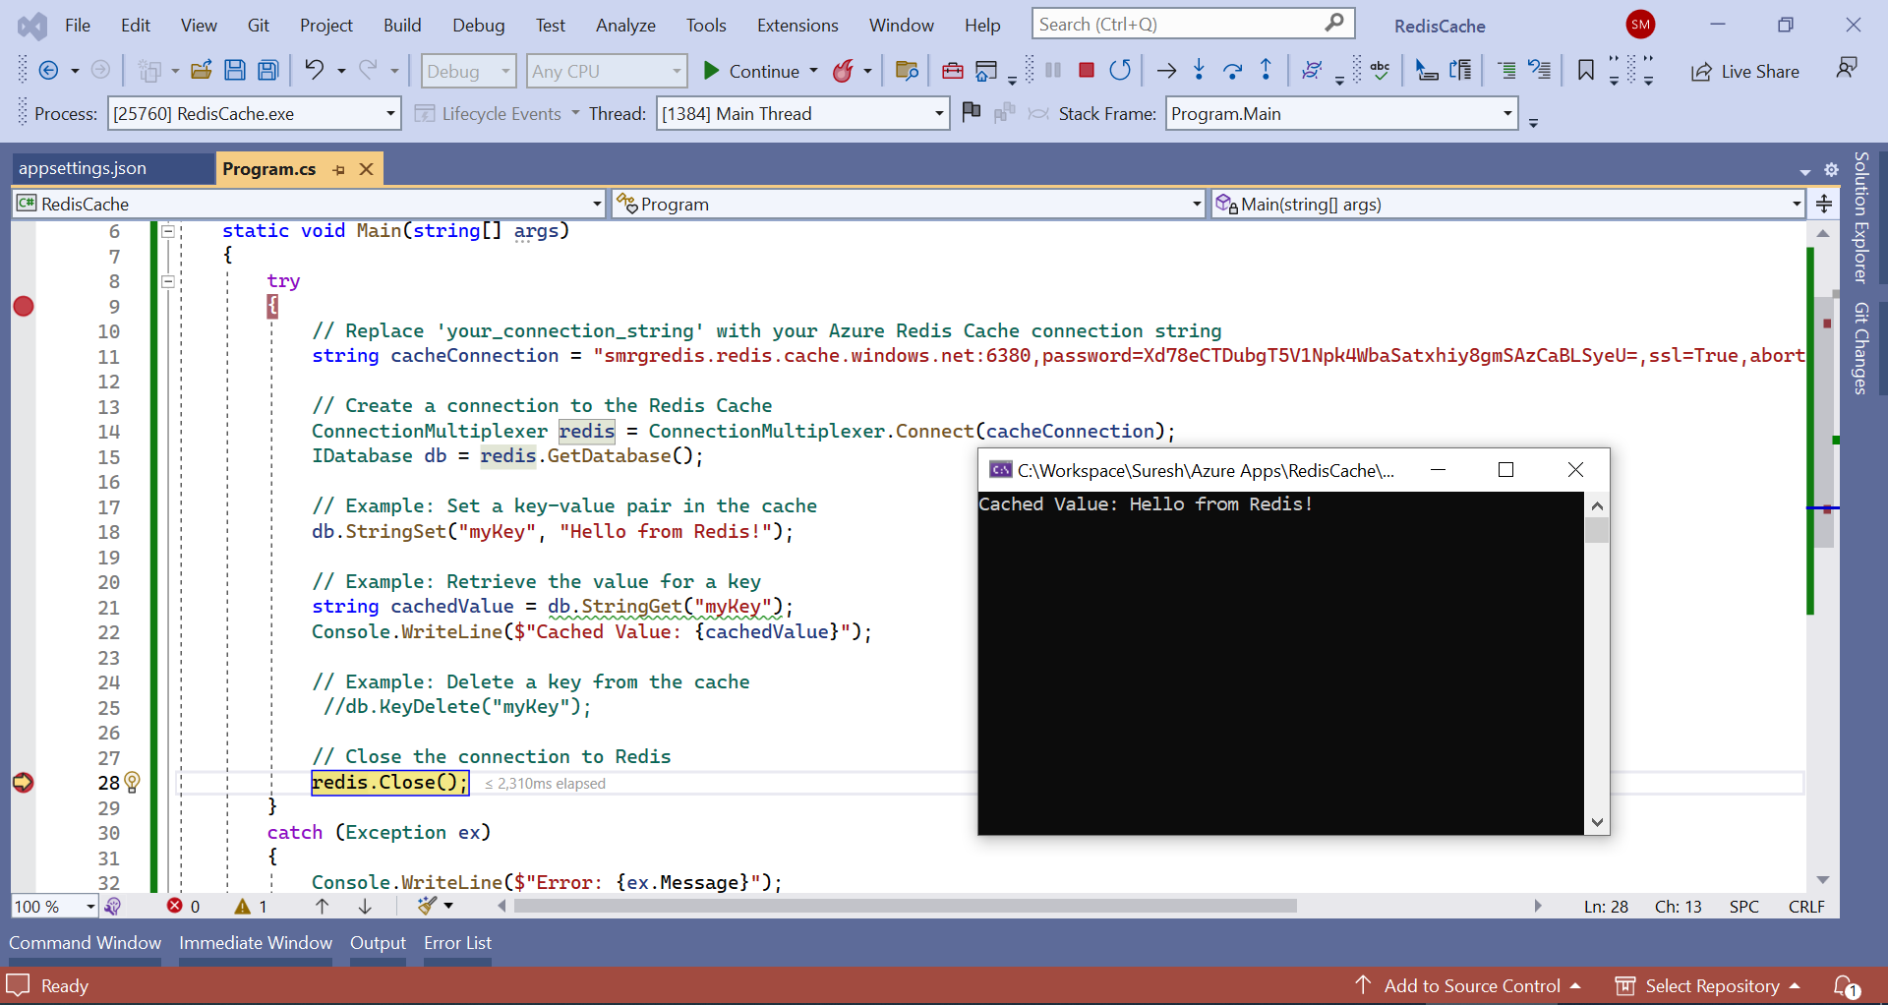

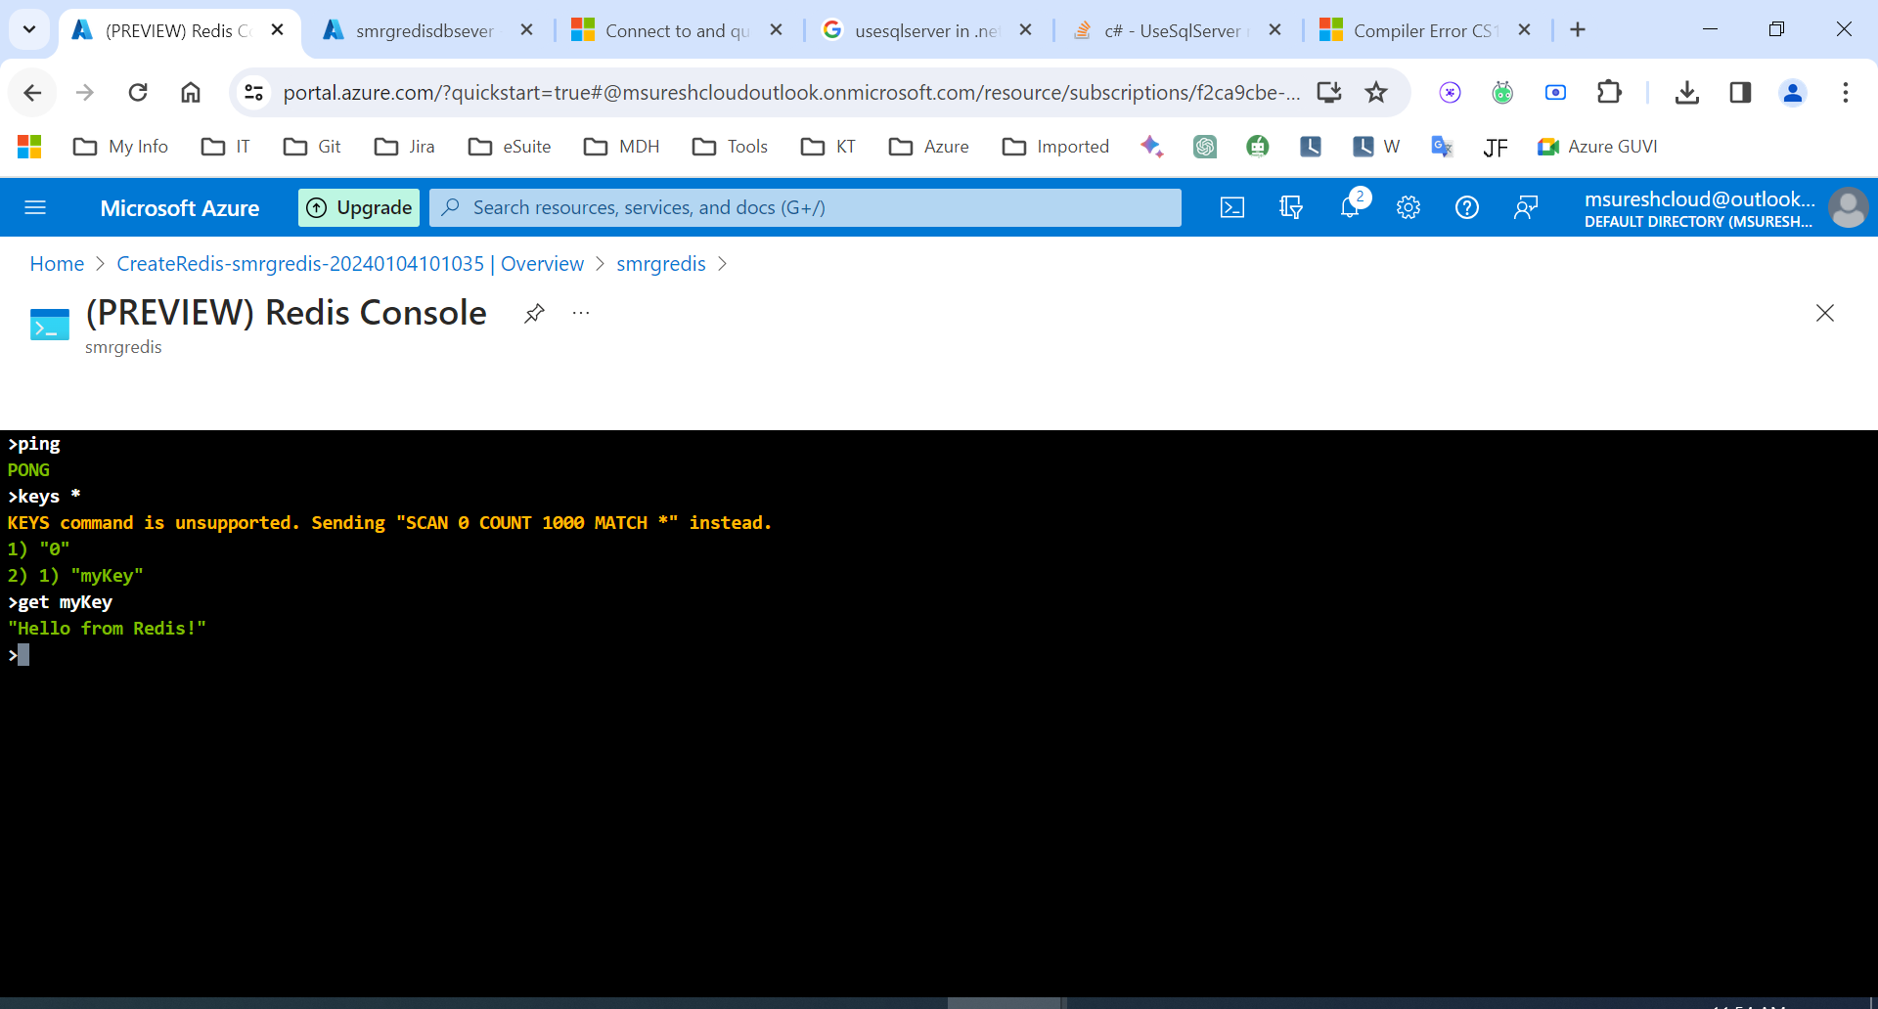

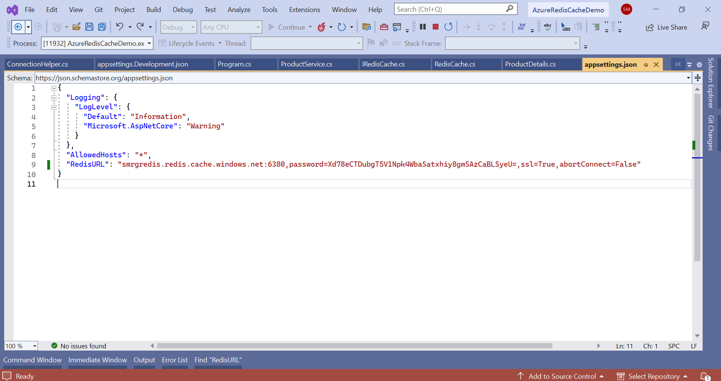

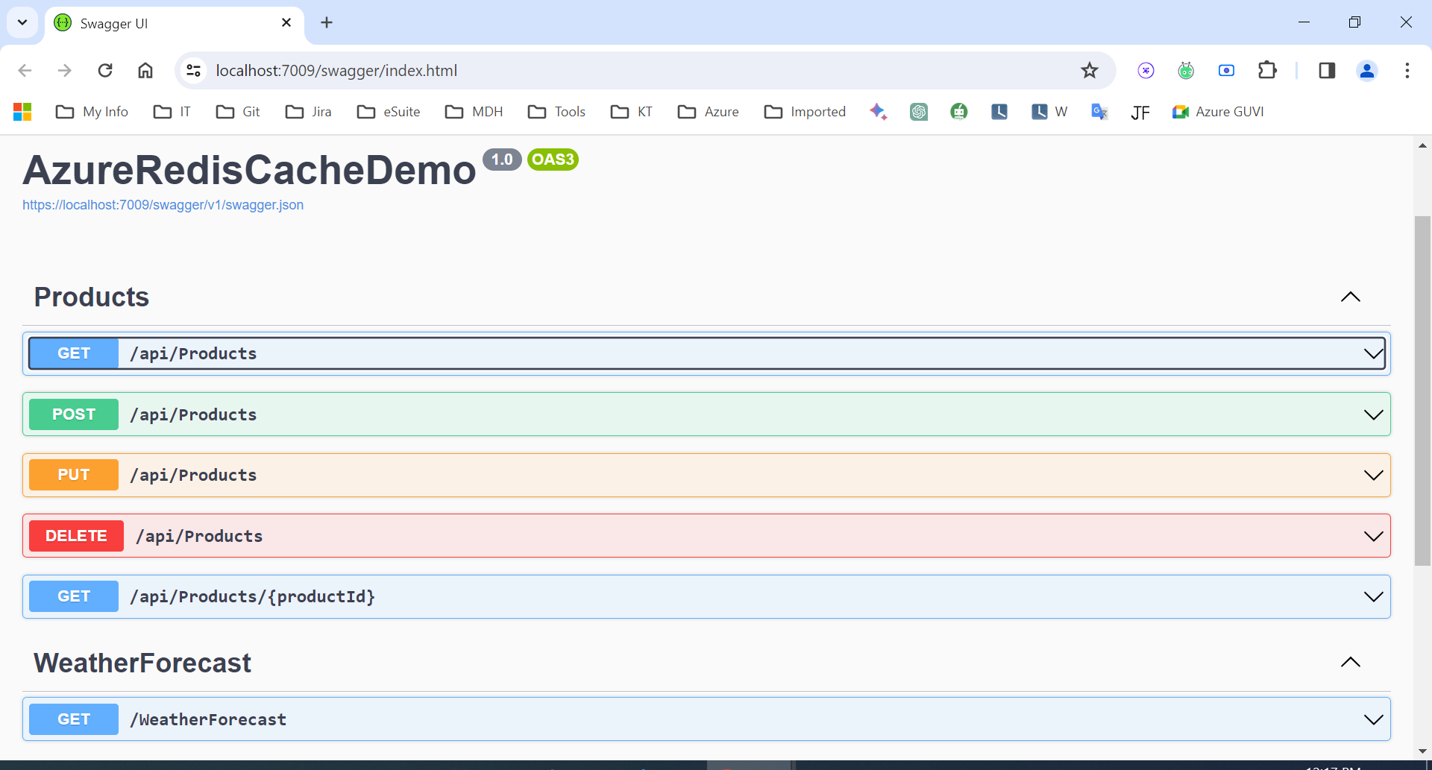

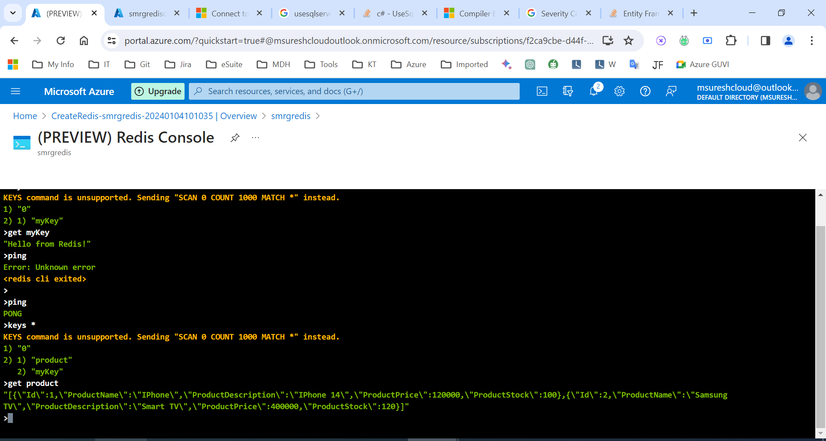

Lab 5: <https://microsoftlearning.github.io/AZ-204-DevelopingSolutionsforMicrosoftAzure/Instructions/Labs/AZ-204_lab_06.html>

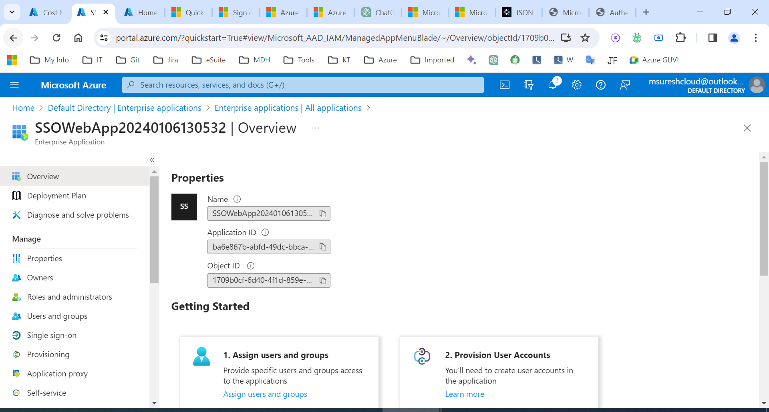

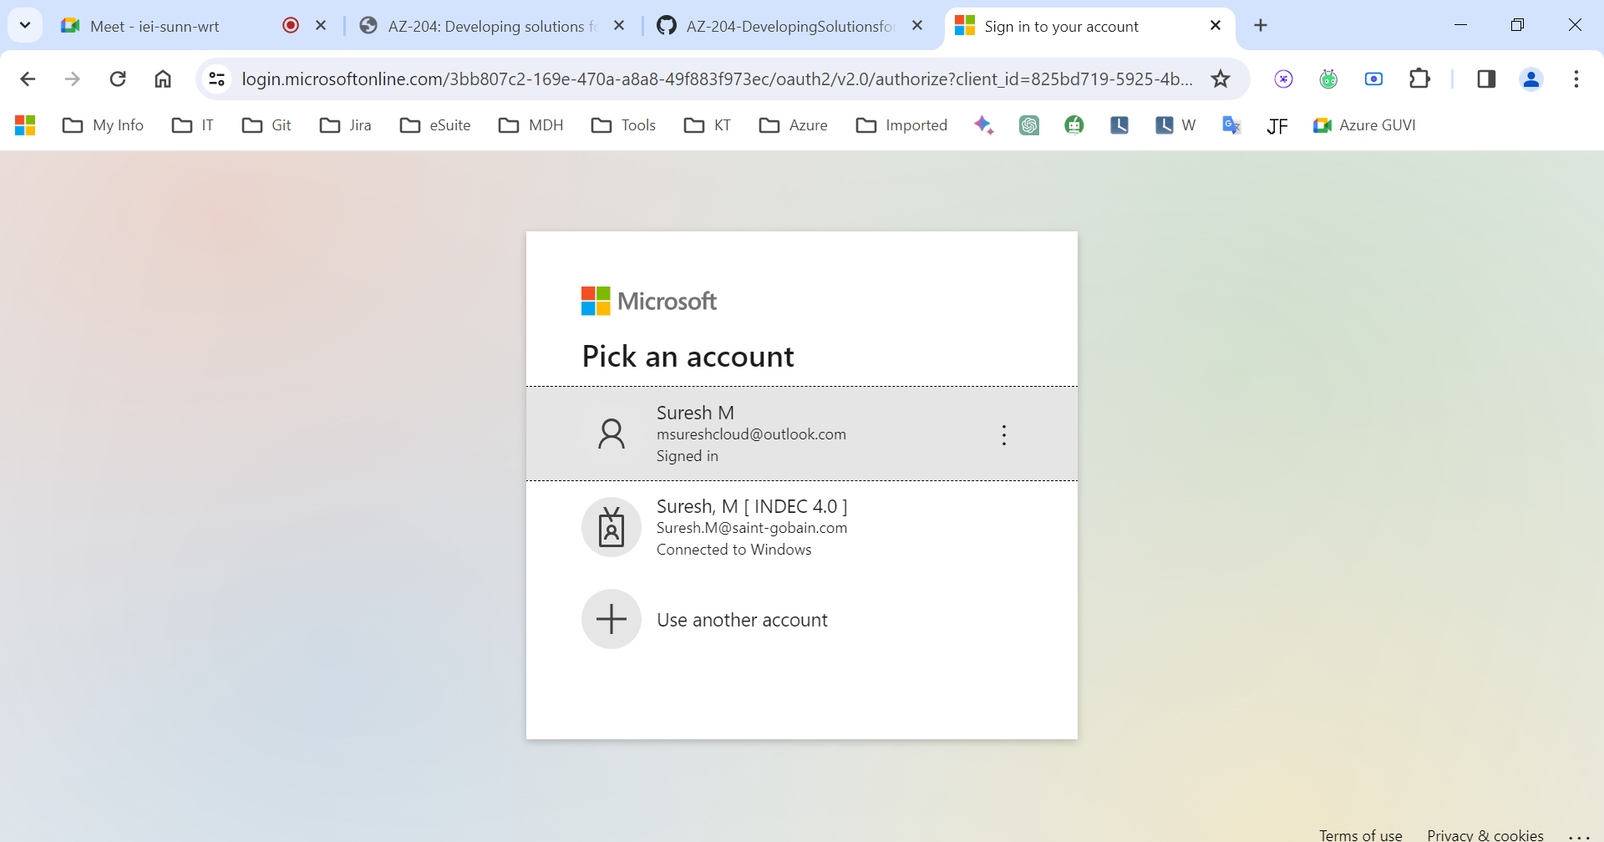

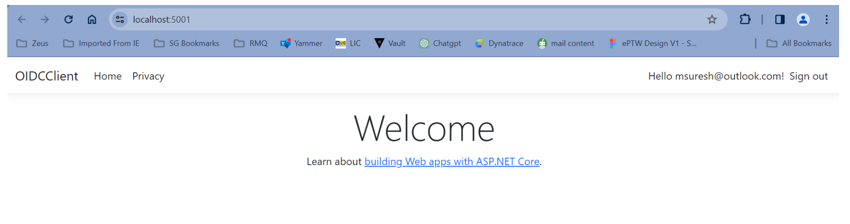

**Lab - 6 Azure Key Vault – :** [**https://github.com/MicrosoftLearning/AZ-204-DevelopingSolutionsforMicrosoftAzure/blob/master/Instructions/Labs/AZ-204_lab_07.md**](https://github.com/MicrosoftLearning/AZ-204-DevelopingSolutionsforMicrosoftAzure/blob/master/Instructions/Labs/AZ-204_lab_07.md)

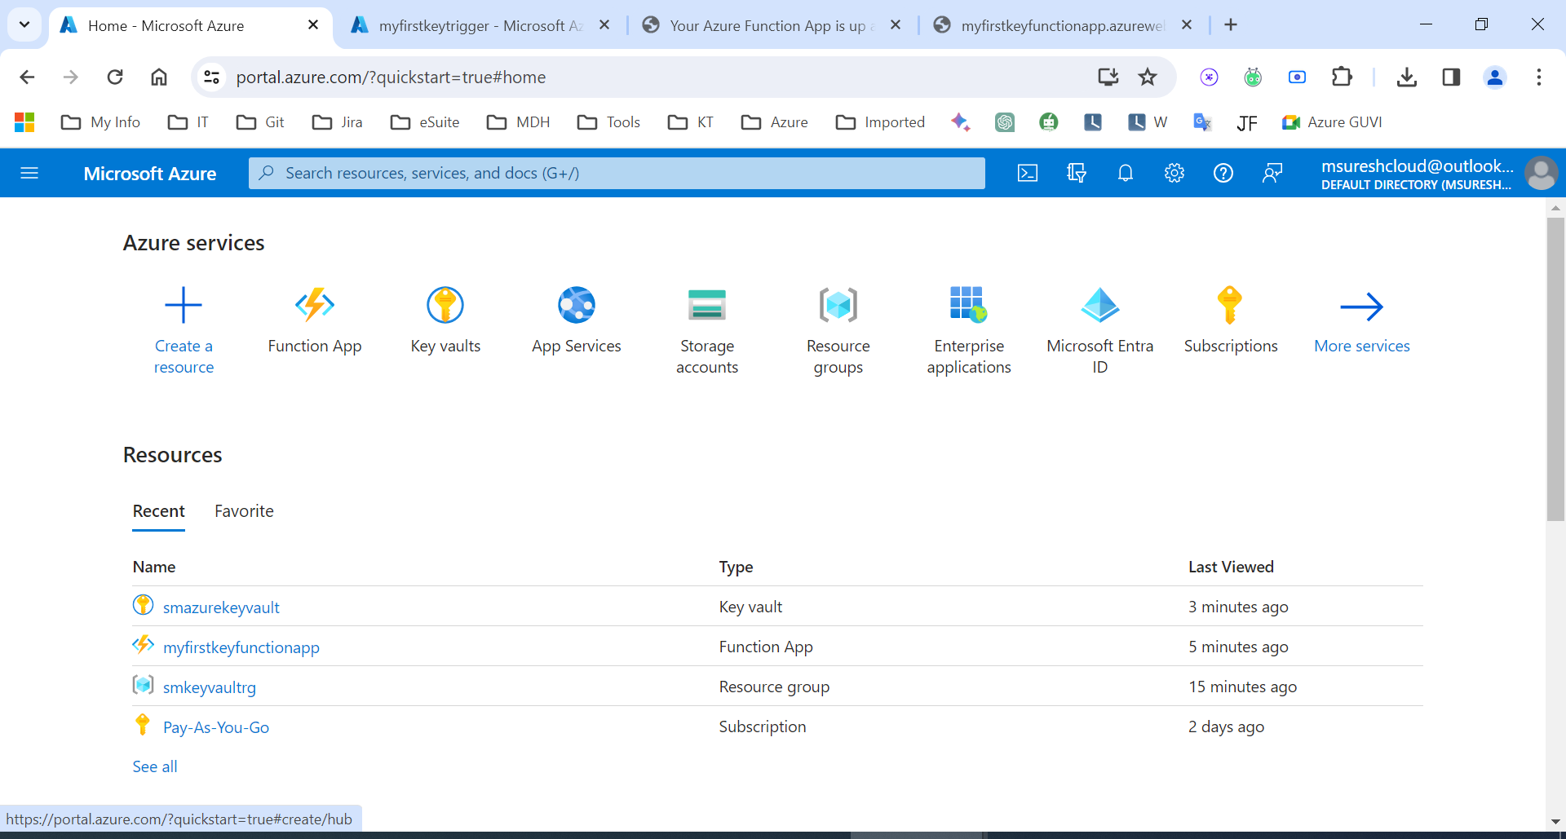

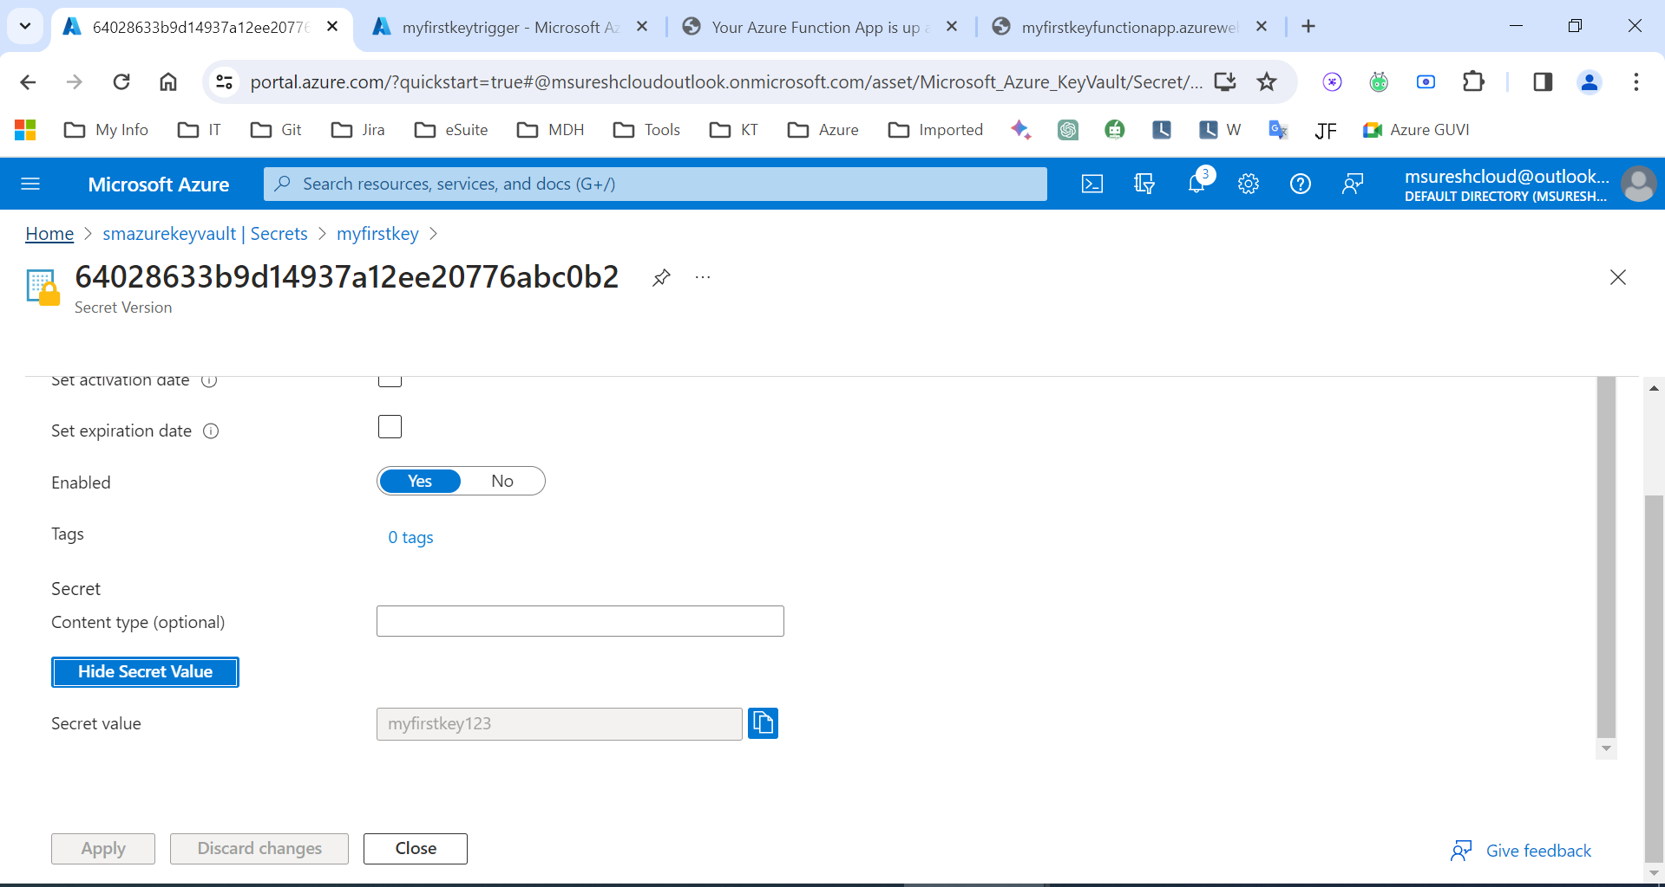

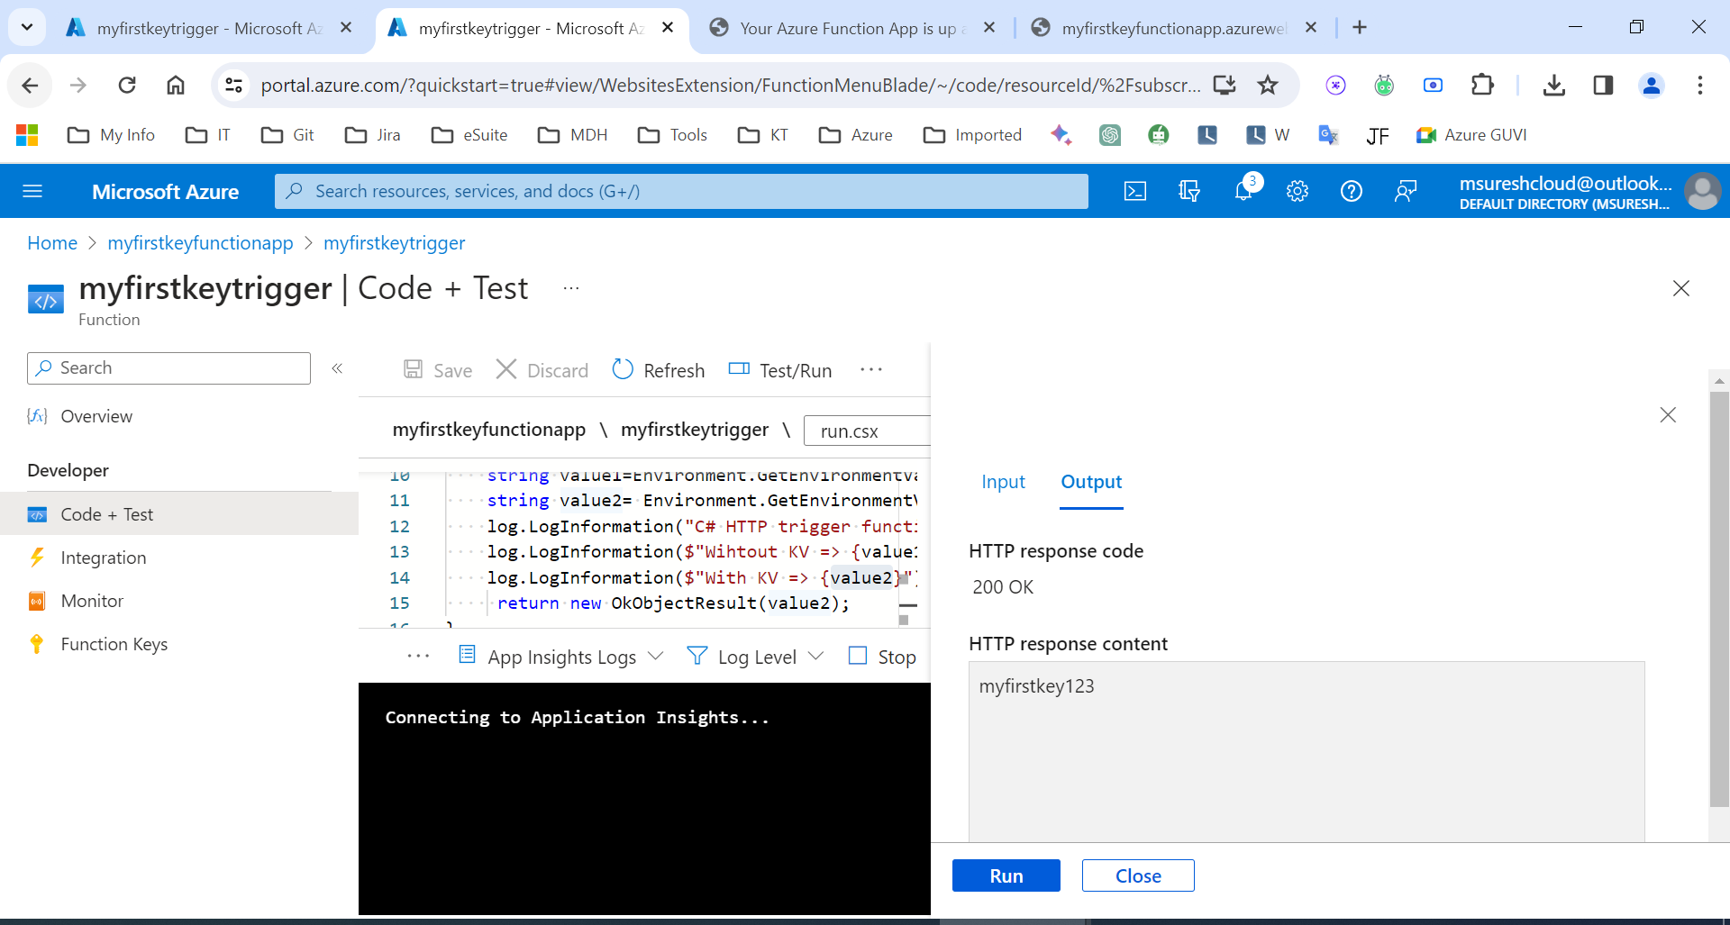

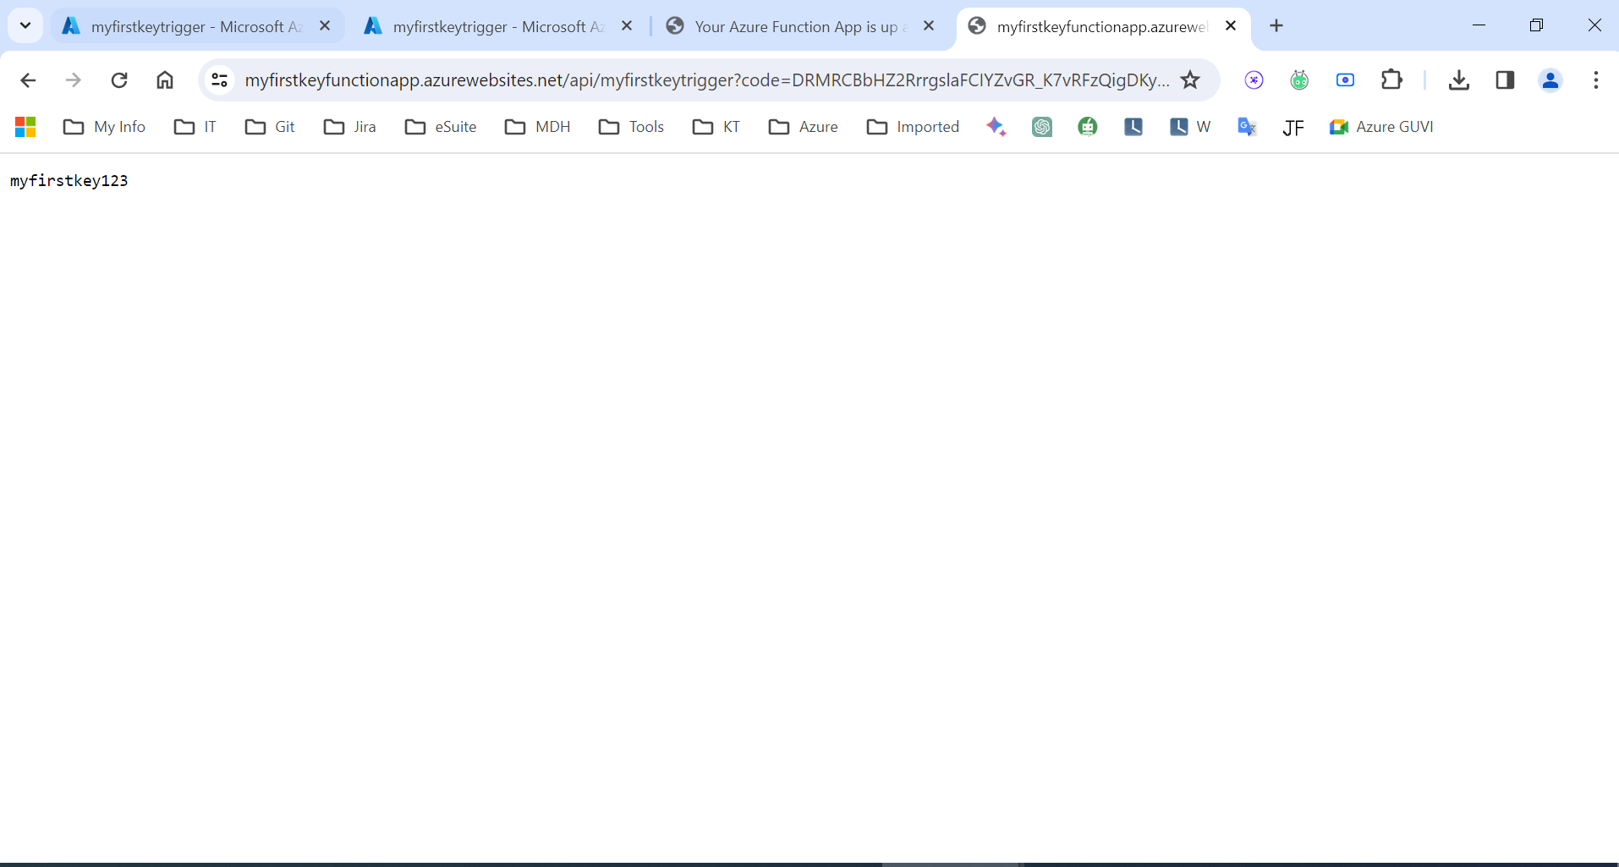

**Lab – 7 Service Bus:** [**https://github.com/MicrosoftLearning/AZ-204-DevelopingSolutionsforMicrosoftAzure/blob/master/Instructions/Labs/AZ-204_lab_10.md**](https://github.com/MicrosoftLearning/AZ-204-DevelopingSolutionsforMicrosoftAzure/blob/master/Instructions/Labs/AZ-204_lab_10.md)

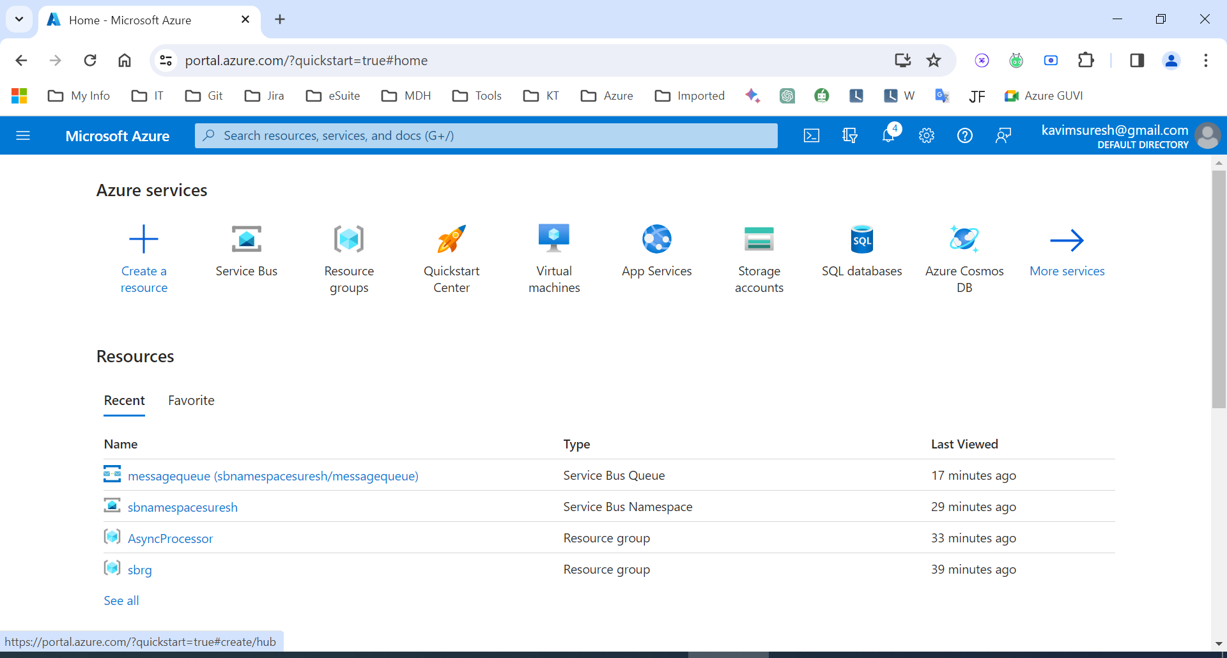

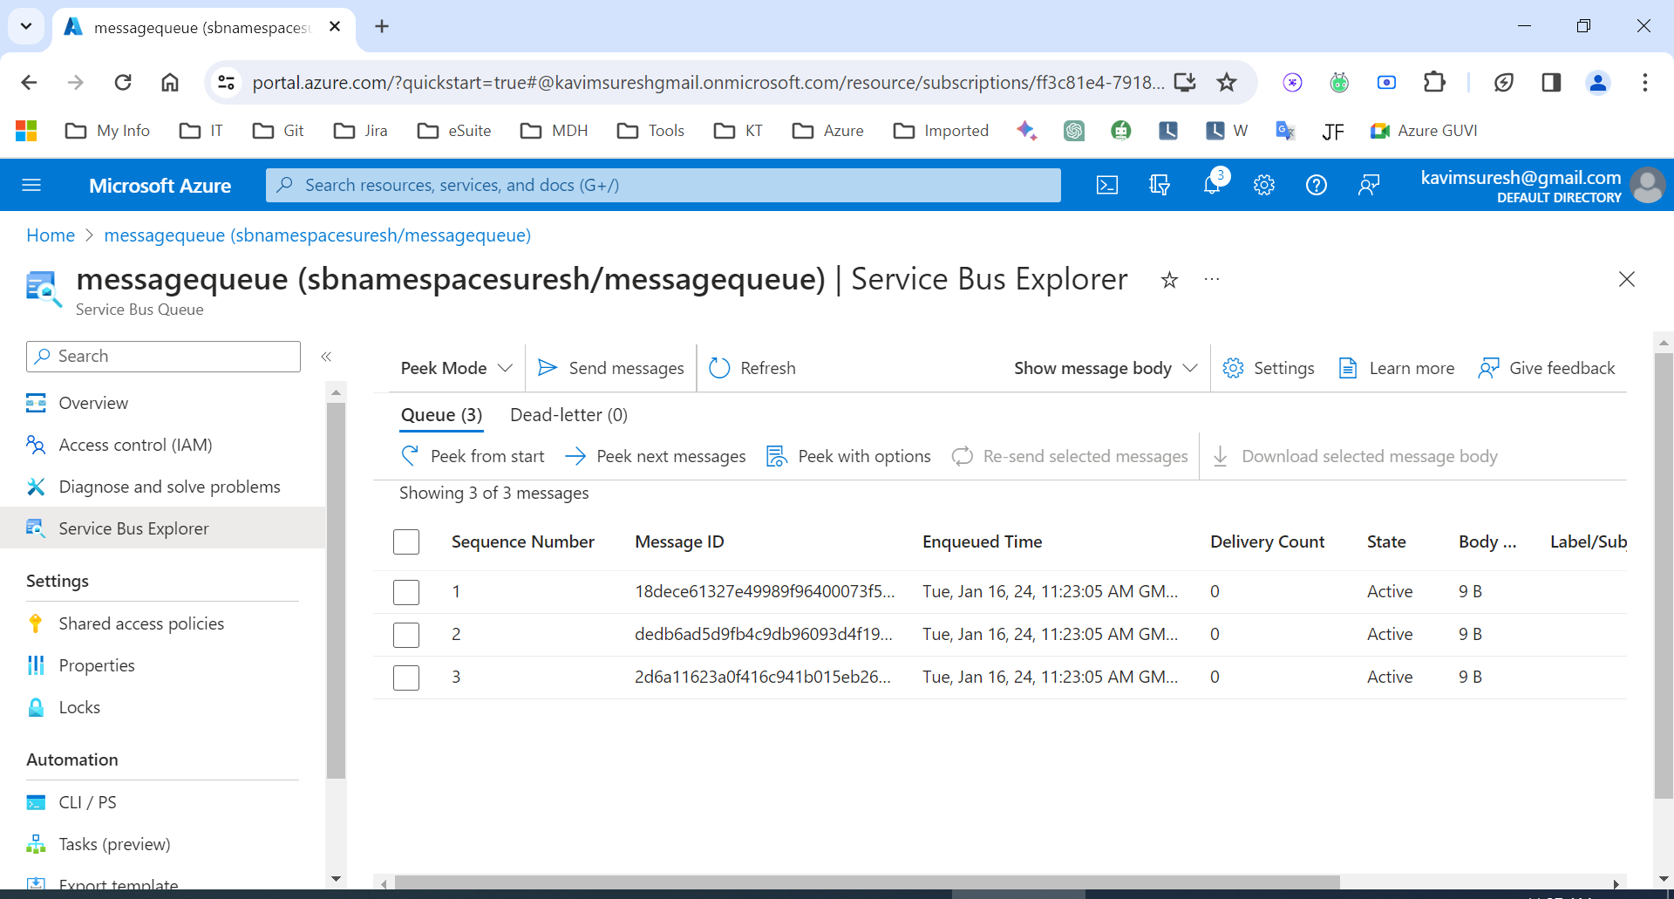

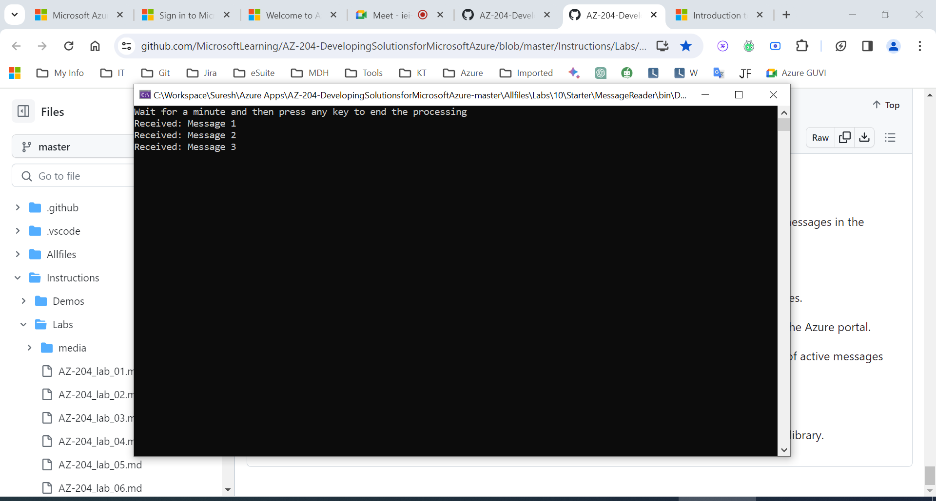

**Lab 8: API Management**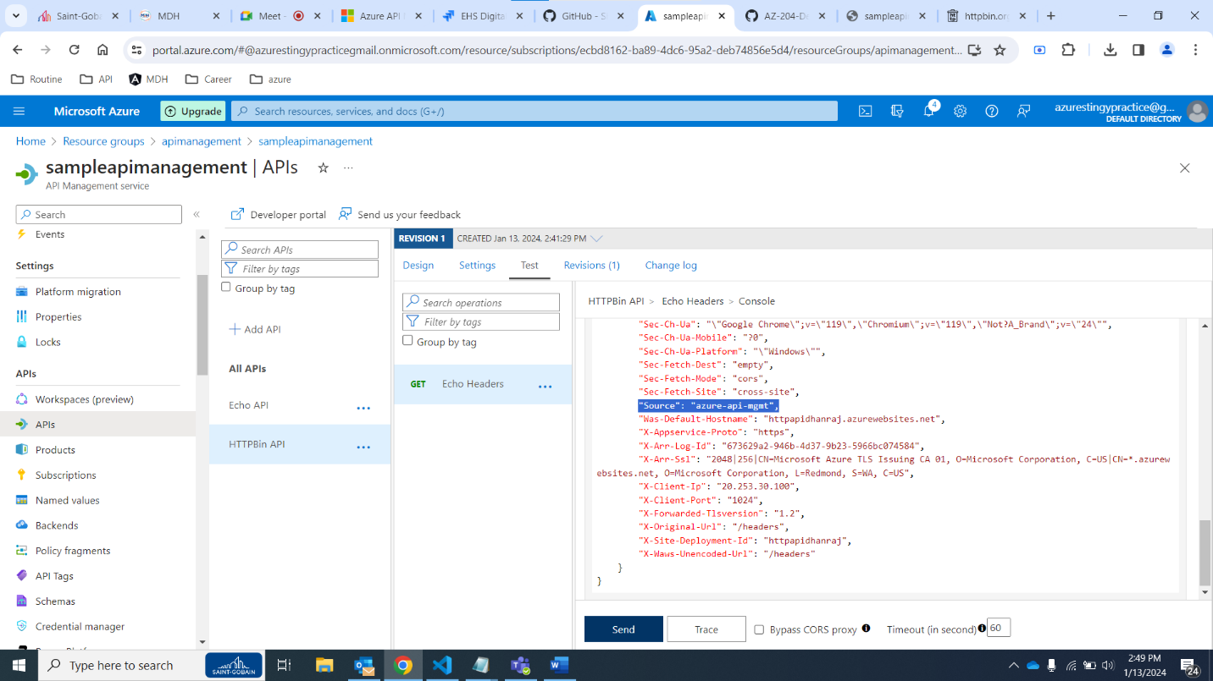

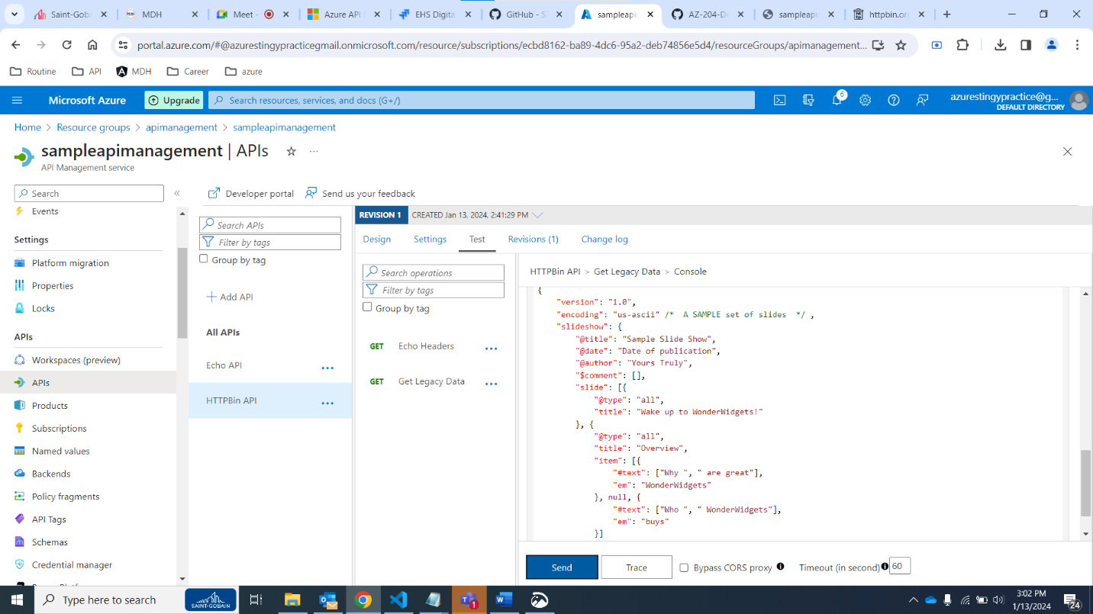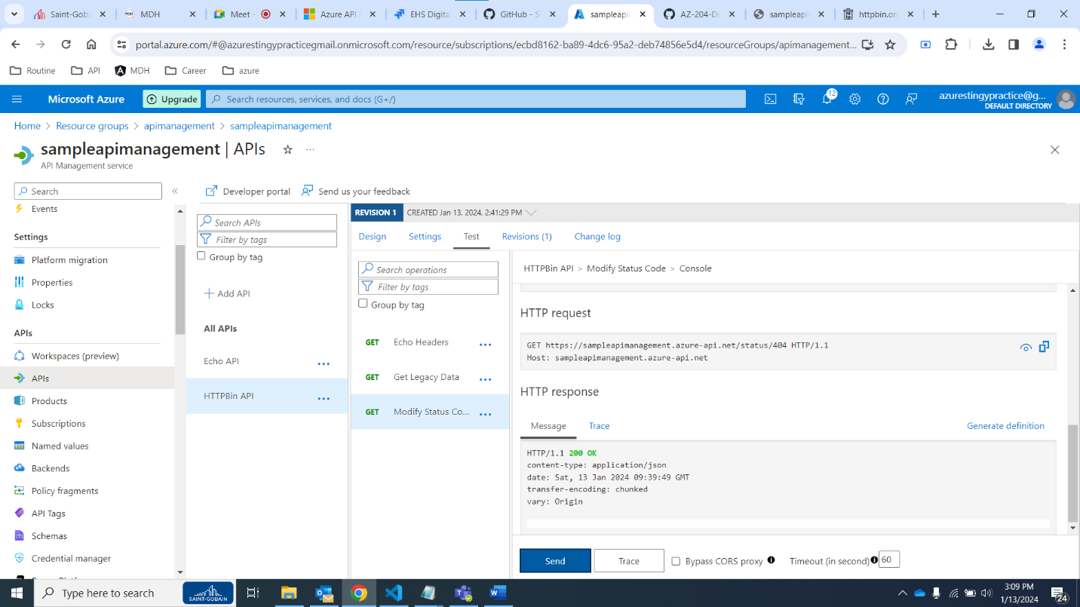 **Lab Logic apps: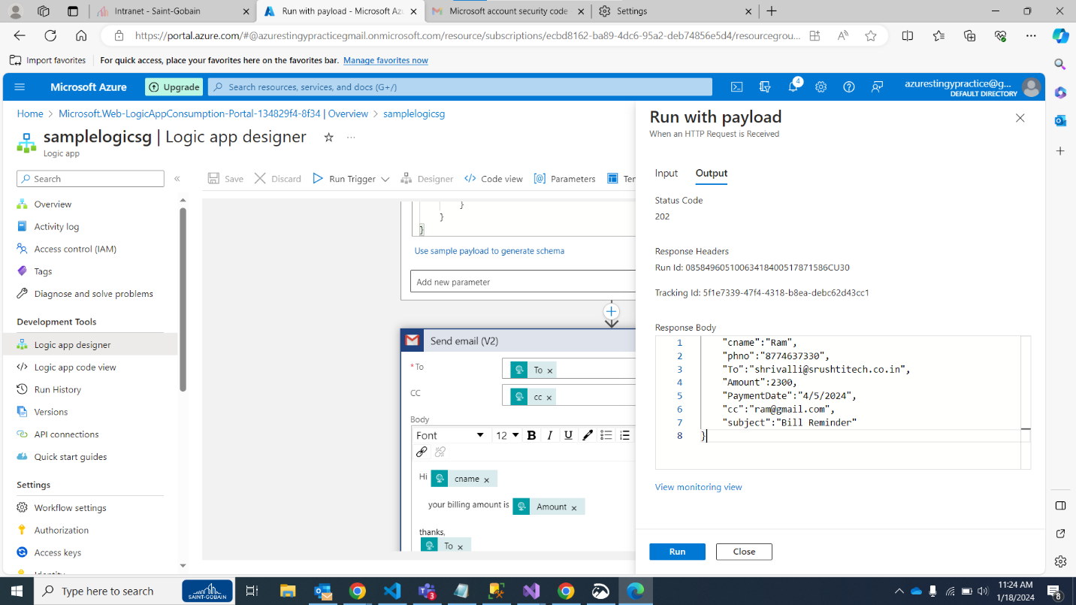 Lab Kubernet:**